REPORT DEVELOPMENT - GUIDELINES
(Crystal Reports)

- Report Design For Transaction Prints
Report page Setup:
Portrait:
All the transaction reports should generally be printed in Portrait setup.
All the reports should be flexibly designed to print in customer specified paper.

Page Header:

- The logo, company name, address should be specified in this section.
- The “Logo” should be placed on left top corner of the report. The Logo should be read from Disk file, the path of the file will be stored in Database.
- Company Name should be aligned left adjacent to the logo, with upper case and emphasized “Bold”.
- The address should be specified fully, with the city and pin code. If the phone number and fax number are needed they should also be printed.
- These details must be encapsulated in a box shaped outline.

Tahoma, 12 pt
Tahoma, 12 pt, Bold, Navy


Tahoma, 12 pt, Bold, Navy

Tahoma, 8 pt, Normal

- If the report is an internal document, address, phone no., fax, email, website are not necessary. In case of report being an external document, then address is compulsory.
External documents:
Purchase Order, Invoice, Packing Slip, DC, Service Outpass
Internal documents:
Purchase Requisition, Material Receipt Note, Material Inspection Note
- Report title should be displayed center of the report in this section emphasized “Bold” below the Company name and address section.
- Report title must also be encapsulated in a box shaped outline.


Tahoma, 10 pt, Bold

- Transaction header should be made to print in this section below the report title with a vertical separator if needed encapsulated in a box shaped outline.

Tahoma, 12 pt, Bold
Tahoma, 8 pt, Normal

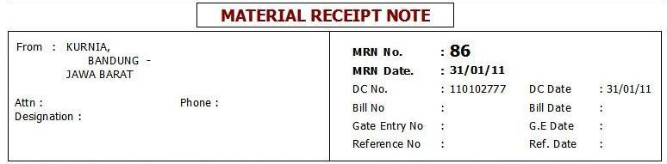

- The heading of the report fields must be emphasized in “Bold”.
- Give explicit column heading accommodating it even to the next line in order to maintain space constraint for the reports that have many fields to display. For example, Print the column heading for “item code” as
Item
Code

- Vertical lines need to be drawn to separate the fields for all the prints wherever it is necessary.
- Column heading should be aligned suitably with the field values as such specified in the following
- Numeric Data : Right aligned.
- Alphanumeric Data : Left aligned.
Tahoma, 8 pt, Bold, Purple

Details:

- Center the columns of the report within the header lines. The total width occupied by the column contents should be centered within the printed space.
- When the same report print is needed within a range (i.e.) when a From and To document number is specified for printing, then grouping of that particular document number is needed in report with the formatting of the group footer section’s “Reset Page Number After” and “New Page After”, ”Keep Together” options checked.
Options Checked

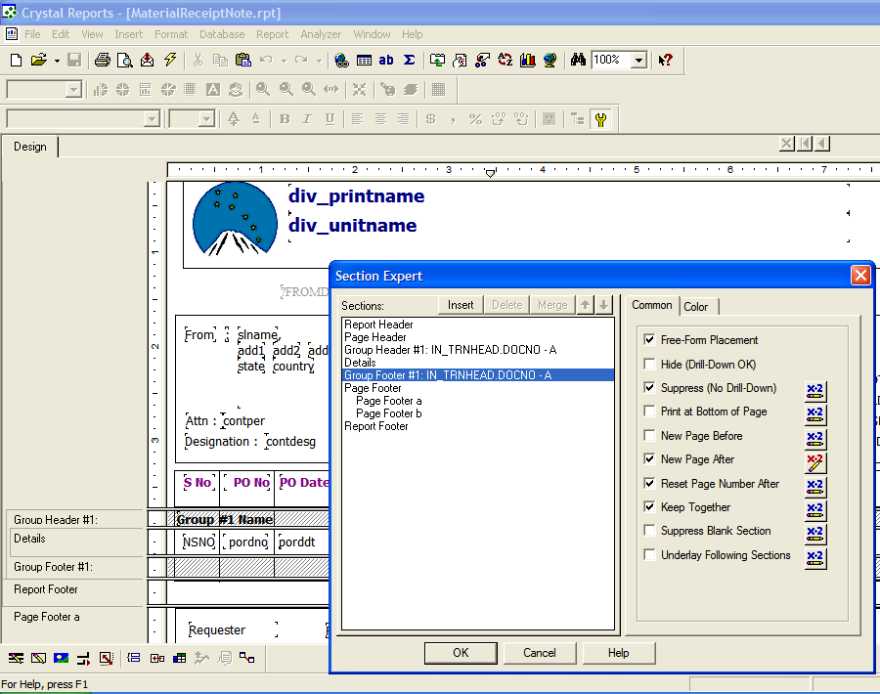

- The field values should be properly customized with the relevant decimal places as
Quantity : 3 decimals
Value & Rate : 2 decimals
Example:
Rate Quantity Value
99,999.99 9,999.999 9,999.99
- Quantity field by default should have a maximum of three decimal places and in reports where space is needed, it can be reduced to two decimals or one.
- If the content of the data fetched is too long, it should be displayed in two lines for the reports that incorporate many fields in it. This can be done with the option “Can Grow” checked in the particular field’s formatting editor.

Example:
Item Name Rate
PSF 2.4D X 22MM GRADE-A 99,999.99
Metal grey lmw

- Zero values should be suppressed, unless they are specified to be needed as such in the specification given.
- Duplication of data is to be suppressed in cases where needed.
Tahoma, 8 pt, Normal

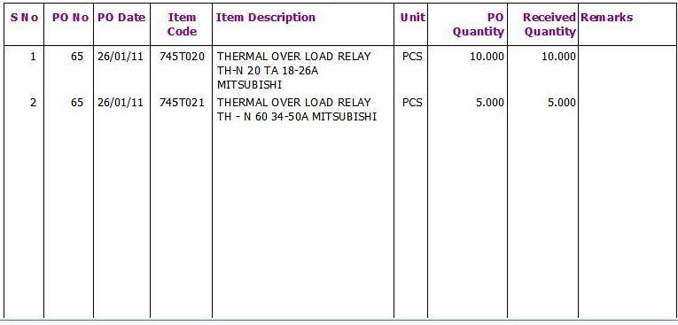

Report Footer:

- If the report contains any details that are to be displayed such as grand total can be made to print in this section.

Page Footer:

- If the report contains any details that are to be displayed at the end of the page, then it is made to print in the “Page Footer” section of the crystal report.
- If the report contains approval lists then that list should be printed here in a horizontal manner.
- Foot notes, if any, must be displayed in this section.
- The page number, if needed should be given at the right bottom in the format “Page N of M”.

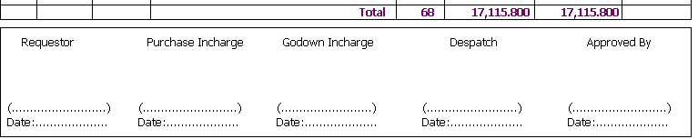

- Report Design For Register Reports
Report page Setup:
Landscape:
All register reports are generally to be printed in Landscape setup.

Portrait:
Exceptional reports such as Stock on date, Consumption register and where only less fields are to be displayed can be printed in portrait setup.

Page Header:

- Company Name and Division name, specified in this section, should be justified center to the report, with upper case and emphasized “Bold”.

Tahoma, 12 pt, Bold

- The report title should be displayed on this section of the report on the left top emphasized “Bold”.
- If the report is supposed to be a register, then the type of register should be mentioned in the center of the report as in the format “Option : Typewise”
Eg.
Purchase Order Register From dd/mm/yy To dd/mm/yy
Tahoma, 10 pt, Bold
Option : Datewise
- Print processing date of the report at the right top, straight to the heading in the format “dd/mm/yy” without giving any prefixes such as Date or Run Date.
- The page number should also be given at the right top straight to the heading and next to the processing date in the format “Page N of M”

Eg. Purchase Order Register dd/mm/yy To dd/mm/yy 09/10/10 Page 1 of 250
Option : Datewise
- The “Option: Typewise” must be specified if at all needed only and not in all respects.
- The heading of the report fields should be emphasized in “Bold”.
Tahoma, 8 pt, Normal

- Give explicit column heading accommodating it even to the next line in order to maintain space constraint for the reports that have many fields to display. For example, Print the column heading for “Item Code” as
Item
Code

Tahoma, 8 pt, Bold, Purple

Tahoma, 10 pt, Meroon, Bold
Tahoma, 8 pt, Normal
Tahoma, 8 pt, Bold

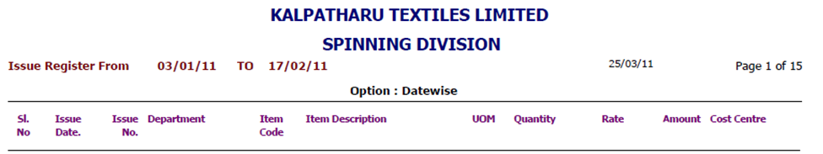

- Column heading should be aligned suitably with the field values as such specified in the following
- Numeric Data : Right aligned.
- Alphanumeric Data : Left aligned.

- Report title, Option, Processing Date, Page number along with the count should be printed in the same line. If needed “Option: Typewise” can be printed in the next line whereas others remain in the same line.

Details:

- Center the columns of the report within the header lines. The total width occupied by the column contents should be centered within the printed space.
- If grouping is done, sub totals should be placed on the suitable group footer as to provide a clear picture for what the sub total is, when more than one grouping is done.
- The field values should be properly customized with the relevant decimal places as
Quantity : 3 decimals
Value & Rate : 2 decimals
Example:
Rate Quantity Value
99,999.99 9,999.999 9,999.99
- Quantity field by default should have a maximum of three decimal places and in reports where space is needed, it can be reduced to two decimals or one.
- If the content of the data fetched is too long, it should be displayed in two lines for the reports that incorporate many fields in it. This can be done with the option “Can Grow” checked in the particular field’s formatting editor.

Example:
Item Name Rate
PSF 2.4D X 22MM GRADE-A 99,999.99
Metal grey lmw

- The apportianate details should be given on the suitable group header when grouped.
- Zero values should be suppressed, unless they are specified to be needed as such in the specification given.
- The duplication of values may be done in cases where it is needed.

Suppressing of duplication

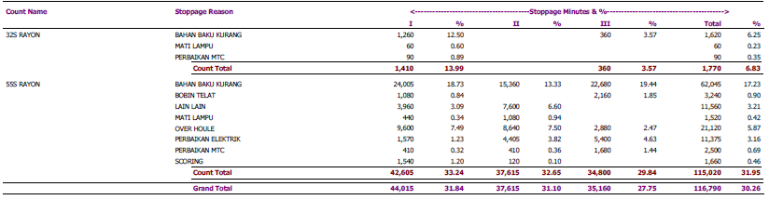

- If the group headings are specified, they should be displayed repeatedly on each new page.
- A single line space should be left or a line should be drawn before and after to separate the subtotals in order to maintain report consistency.
- Avoid two lines report except for the apportianate and detail reports.
- Avoid vertical lines in report to separate the fields unless required by the customer.

Tahoma, 8 pt, Bold
Tahoma, 8 pt, Normal

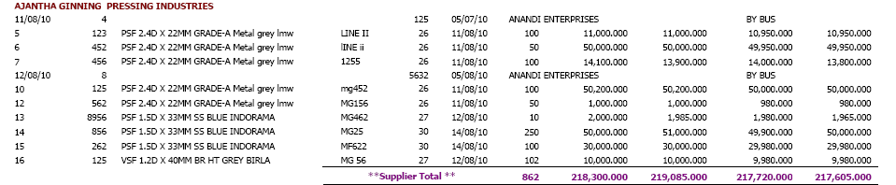

- When values of subtotal or grand total exceed the space provided, then the subtotal as well as the grand total can be printed in two lines with the step structure.
Tahoma, 8 pt, Bold, Purple, Values are displayed in two lines

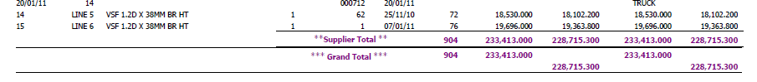

Report Footer:

- The grand total, if any should be displayed on this section of the report.
- A single line space should be left or a line should be drawn before and after specifying the grand total.
- A line should be drawn in between group total and grand total in order to differentiate them and maintain consistency.
- If the report contains any abstracts or sub reports then it should be indicated or placed here to maintain report consistency.

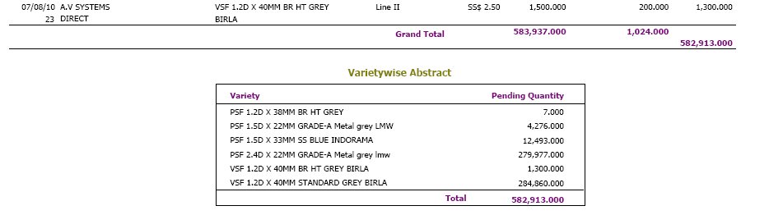
Tahoma, 10 pt, Bold, Meroon
Sub report
Tahoma, 8 pt, Bold, Purple

Tahoma, 8 pt, Normal

- Cross tab reports, if designed should be placed either in the report footer section or at the report header section.

Page Footer:

- If the report contains any details that are to be displayed at the end of the page, then it is made to print in the “Page Footer” section of the crystal report.
- If the report contains multiple pages, then border lines and certain conditions should be displayed here.
- If this section contains any formatting, if the report is a register, then the formatting should be suppressed in the last page of the report.
- Foot notes, if any, must be displayed in this section.

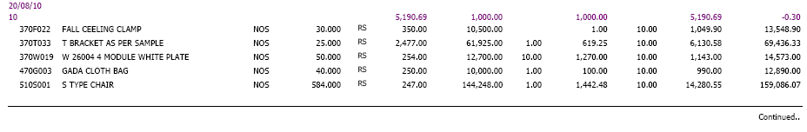

- Report Design For Cross Tab reports
Report page Setup:
Landscape:
Since the numbers of columns of cross tab reports are not fixed, they are to be printed in landscape setup.

- When the number of columns is unpredictable, Cross Tab reports can be used.
- Cross-tab reports are a powerful way to create summaries of data in a spreadsheet style format.
- They generate summary data in a grid where the rows and columns represent groups of data.
- This provides the user with a report format that is easy to read and uses a small footprint on the page.
- Cross-tab report format groups of data into an easy to read grid format.
Cross Tab report

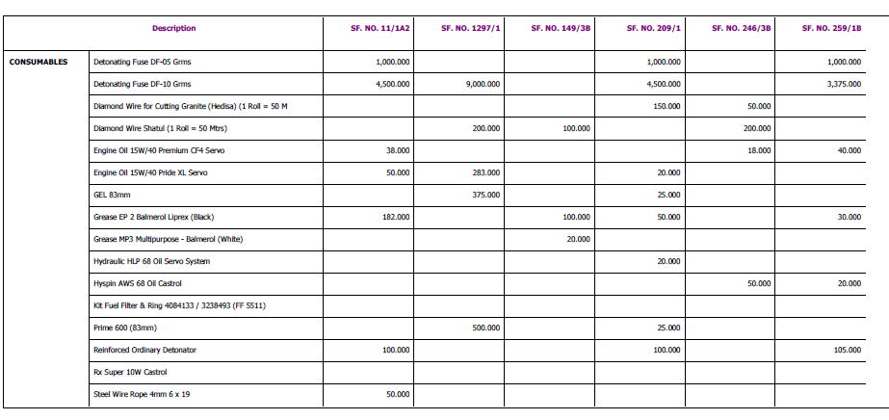
Tahoma, 8pt, Bold
Tahoma, 8pt, Bold, Purple

Tahoma, 8pt, Normal

